|  |
| --- |
| **NATIONAL UNIVERSITY OF SCIENCES AND TECHNOLOGY (NUST)** |
|  |
| **SCHOOL OF ELECTRICAL ENGINEERING AND COMPUTER SCIENCE (SEECS)** |
| EC-303 Mobile Application Development for Small and Medium Enterprises |
| LAB-04  Flutter Basics – Widgets, Material Design, Layouts, and Interactivity |

SYEDA SANA ZEHRA ZAIDI

339278

BESE-11 A

**Task 1**

Follow the guidelines mentioned in <https://codelabs.developers.google.com/codelabs/first-flutter-app-pt1> and follow the step-by-step tutorial.

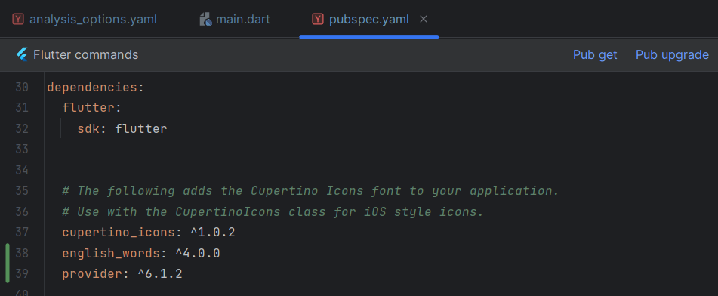

Figure Pubspec.yaml

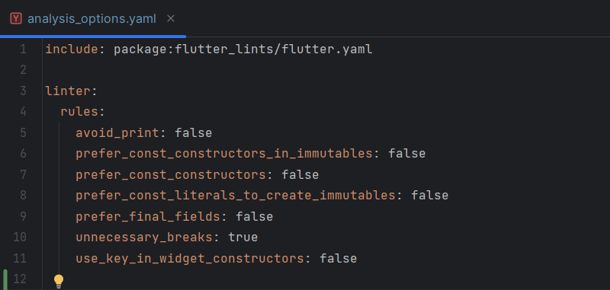

Figure analysis_options.yaml

**lib/main.dart**

|  |
| --- |
| import 'package:english_words/english_words.dart'; import 'package:flutter/material.dart'; import 'package:provider/provider.dart';  void main() {  runApp(MyApp()); }  class MyApp extends StatelessWidget {  const MyApp({super.key});   @override  Widget build(BuildContext context) {  return ChangeNotifierProvider(  create: (context) => MyAppState(),  child: MaterialApp(  title: 'Namer App',  theme: ThemeData(  useMaterial3: true,  colorScheme: ColorScheme.fromSeed(seedColor: Colors.*deepOrange*),  ),  home: MyHomePage(),  ),  );  } }  class MyAppState extends ChangeNotifier {  var current = WordPair.random(); }  class MyHomePage extends StatelessWidget {  @override  Widget build(BuildContext context) {  var appState = context.watch<MyAppState>();   return Scaffold(  body: Column(  children: [  Text('A random idea:'),  Text(appState.current.asLowerCase),  ],  ),  );  } } |

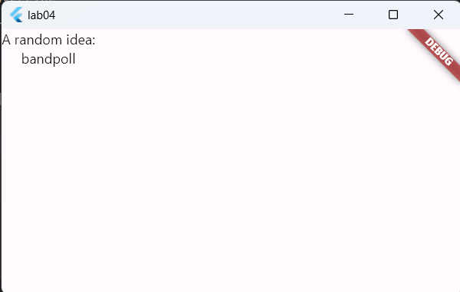

**Checking Hot Reload**

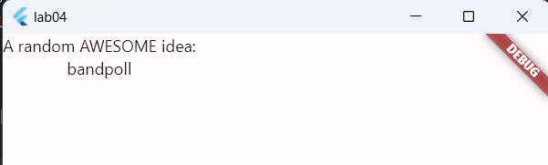

**Adding button to Scaffold**

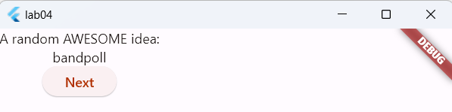

**Whenever ‘Next’ is clicked, ‘button pressed’ is printed on console**

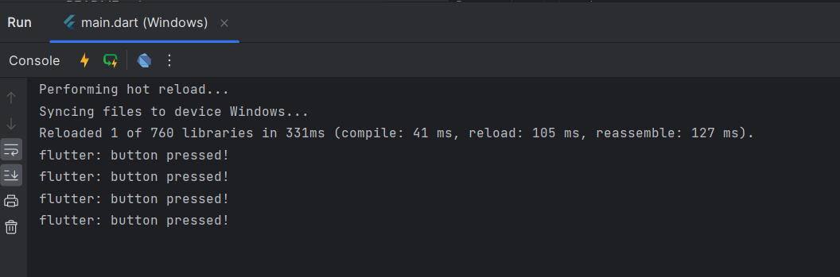

**The ‘Next’ button changes the text displayed on screen**

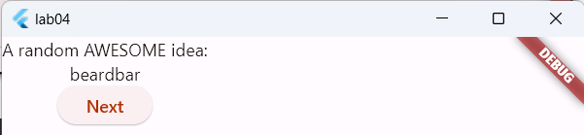

**After wrapping widget with Padding**

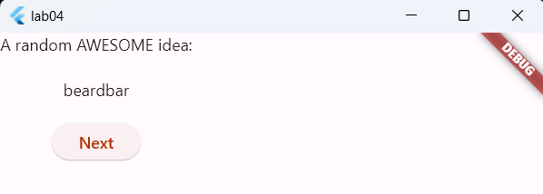

**Wrapping the widget with Card Widget**

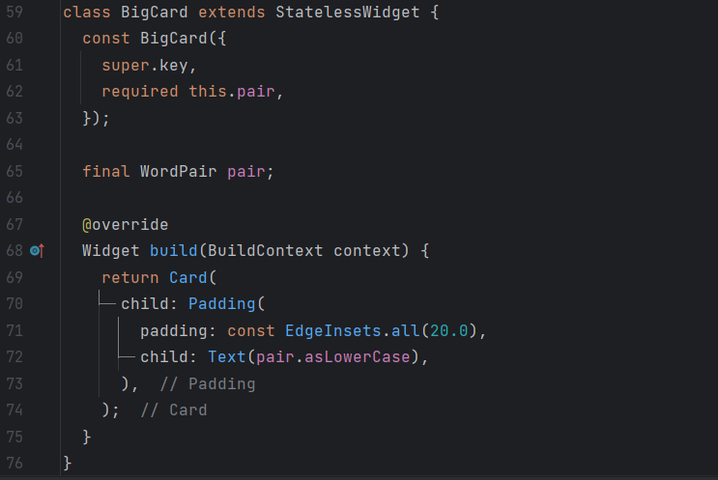

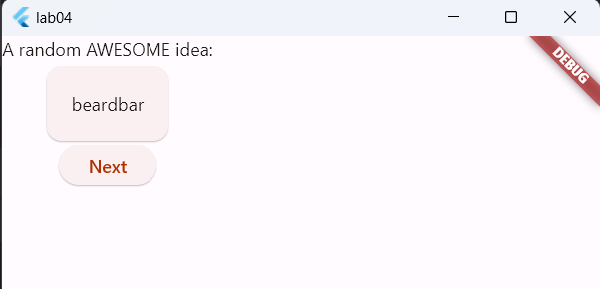

**Applying default color theme to the Card**

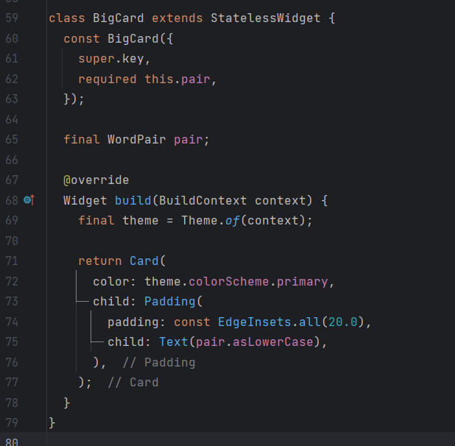

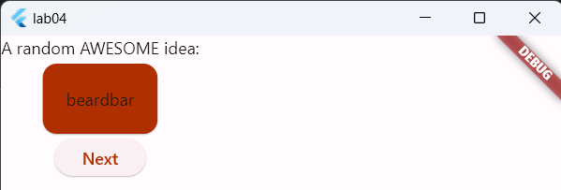

**Using displayMedium textTheme with onPrimary color**

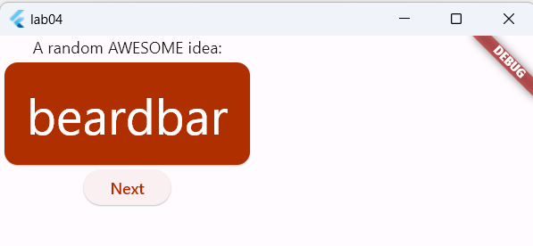

**Adding semantics label**

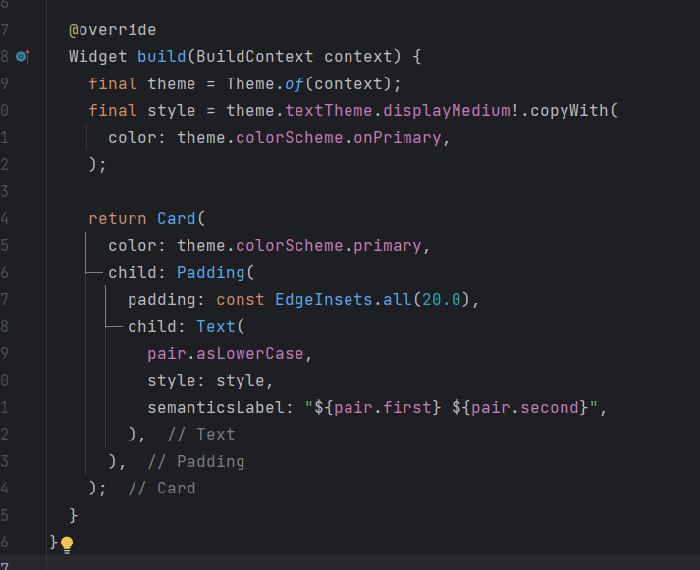

**Moving Card to Column**

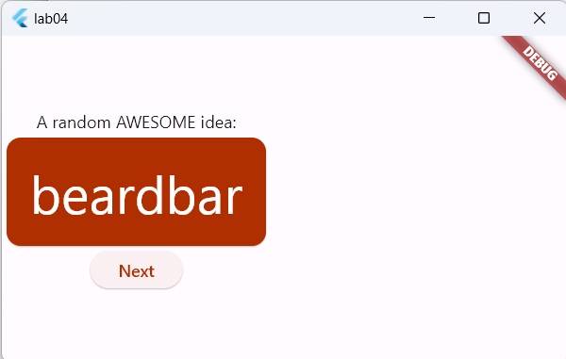

**Wrapping Column with Center**

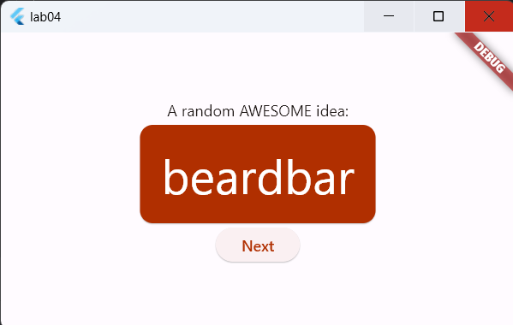

**Added button for toggling like**

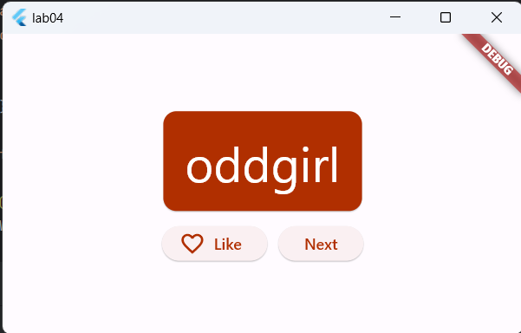

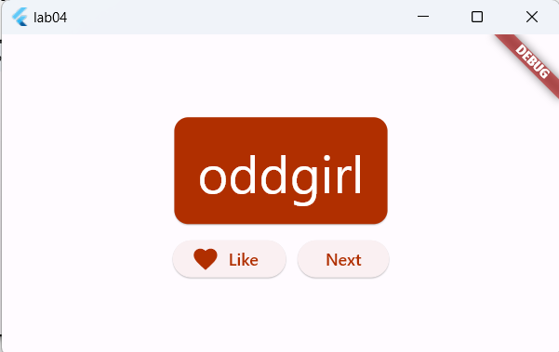

**Added stateful navigation rail**

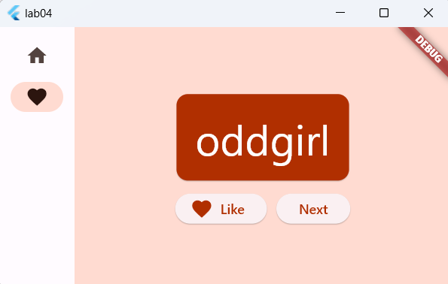

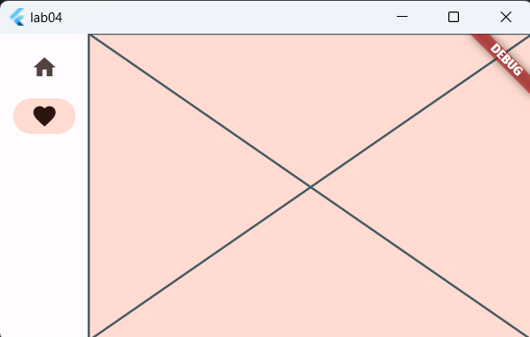

**Adding LayoutBuilder to display menu text on large screens only.**

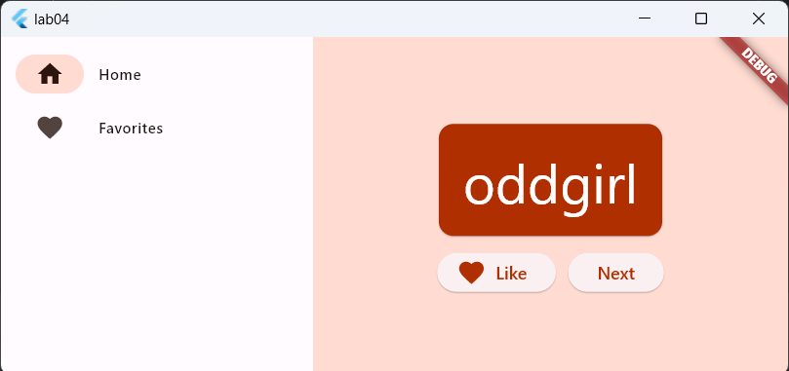

**After creating Favorites Screen**

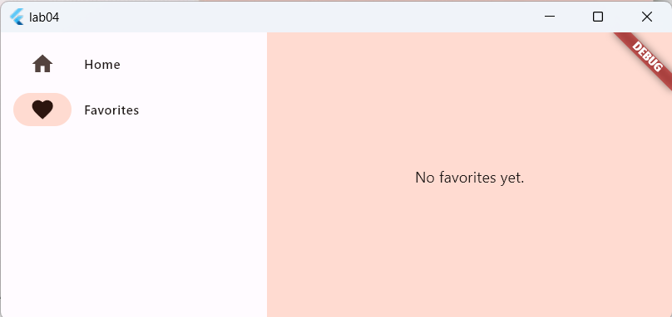

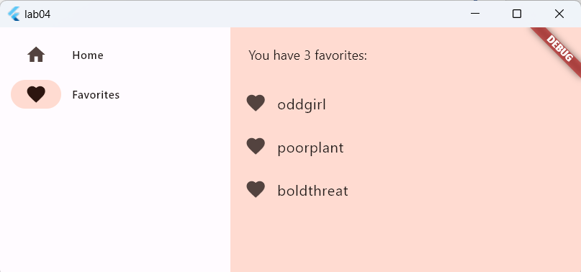

**Task 2**